Sexual Reproduction
Except Fungi Imperfecti, which have now been treated as Anamrphic fungi by kirk et al.(2001), almost all true fungi reproduce sexually. They produce gametes. The gemetes of opposite sex fuse under the process of plasmogamy and karogamy and zygote with its nucleus having diploid number of chromosomes, is formed. The diploid nucleus of the zygote undergoes reduction division to reduce the number of chromosomes to the haploid number.
In all lower fungi (phycomycetes) and a few ascomycetes fungi, sexual reproduction takes place by the fusion of two protoplast, called Gametes.
In many genera the fusion takes place between two gamates of equal size, such gametic union called isogamy, shown in fig 6.13 B. Two fusing gamates are generally flagellated (zoogametes), but some are non flagellated (aplanogametes).
In some genera the fusion takes place between two motile gamates of unequal size. Such a gametic fusion is called anisogamy shown in fig 6.13 C.D. Of these two fusing gamates the smaller one is the male gamete and the larger one is female gamete.
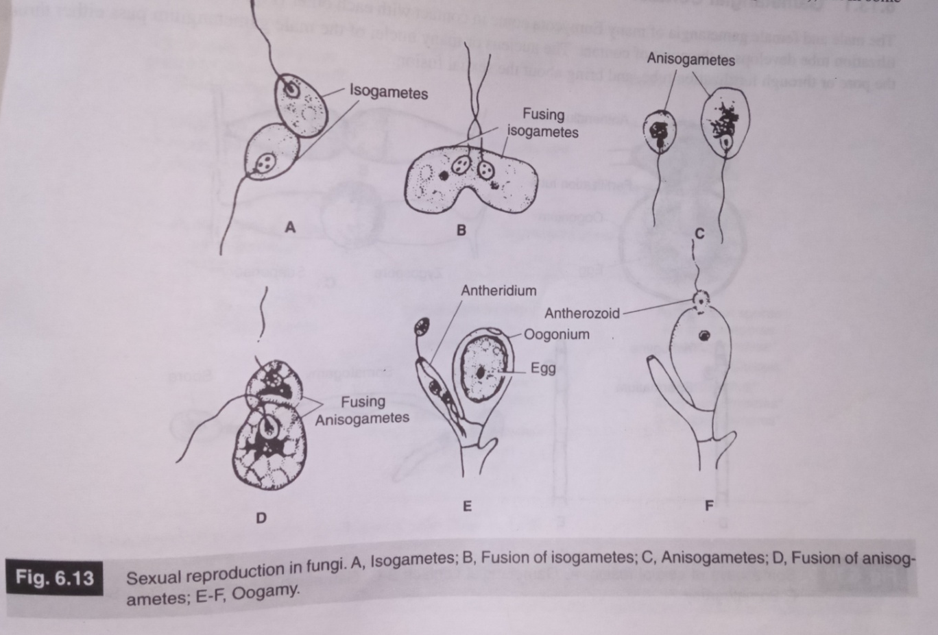
Many Phycomycetous and Ascomycetous genera show oogamy, where the male gamete is smaller, flagetted and motile, and the female gamete larger, non-flagetted and non-motile. The male is called antherozoid, and the female gamete is called egg shown in fig 6.13 E,F.

Phycomycetous fungi- In isogamous and anisogamous Phycomycetes fungi the gamete-containing body is called a gametangium. In oogamous species, the female gametangium is called oogonium, and the male gametangium is called antherdium. Fusion in all cases results into zygote.
Ascomycetes – Ascomycetes show plasmogamy between a small male gamete (spermatium or antherdium) and a large female gametes (ascogonium). Plasmogamy is not followed by karyogamy. Ascus is formed. Karyogamy and meiosis take place in the ascus.
Basidiomycetes- Basidiomycetes gametic union takes place but well defined sex organs are absent. Plasmogamy takes place between protoplast of two vegetative cells or spore. Basidium is formed. Karyogamy and meiois take place only in the basidium.

Glossary -
- Plasmogamy is a stage in the sexual reproduction of fungi, in which the protoplasm of two parent cells (usually from the mycelia) fuses together without the fusion of nuclei, effectively bringing two haploid nuclei close together in the same cell
- Protoplasm is the living part of a cell that is surrounded by a plasma membrane.
- Karyogamy is the final step in the process of fusing together two haploid eukaryotic cells, and refers specifically to the fusion of the two nuclei
- Phycomycetes is an obsolete polyphyletic taxon for certain fungi with aseptate hyphae (non septate)
- Oogamy is the familiar form of sexual reproduction. It is a form of anisogamy (heterogamy) in which the female gamete (e.g. egg cell) is significantly larger than the male gamete and is non-motile.
- An ascus is the sexual spore-bearing cell produced in ascomycete fungi. Each ascus usually contains eight ascospores, produced by meiosis followed, in most species, by a mitotic cell division.
- Basidium is a microscopic club-shaped spore-bearing structure produced by certain fungi

Modes of sexual fusion
Some common methods of sexual fusion, under which the compactible nuclei are brought together, through the process of plasmogamy-
- Gametangial Contact- the male and female gametangia come in contact with each other. Either a pore or a fertilization tube develops at the point of contact. The nucleus or many nuclei of the male gametangium pass either through the pore or through fertilization tube, and bring about sexual fusion as shown in fig 6.14 A
- Gametangial copulation- the gametangia come in contact through their tips. The entire contents of one gametangium are transferred into the other gametangium through a pore in many true fungi, shown in fig 6.14 B,C
- Spermatization- in som fungi, non motile gametes (spermatia) are carried up to the receptive organ of the female gametangium through various agencies like wind, water and insects.shown in fig 6.14 D,E
- Somatogamy- well organized sex organs are absent in many true fungi. In such cases the sexual fusion is brought about by anastomosis of somatic hypahe belonging to two different parents.shown in fig 6.14F.

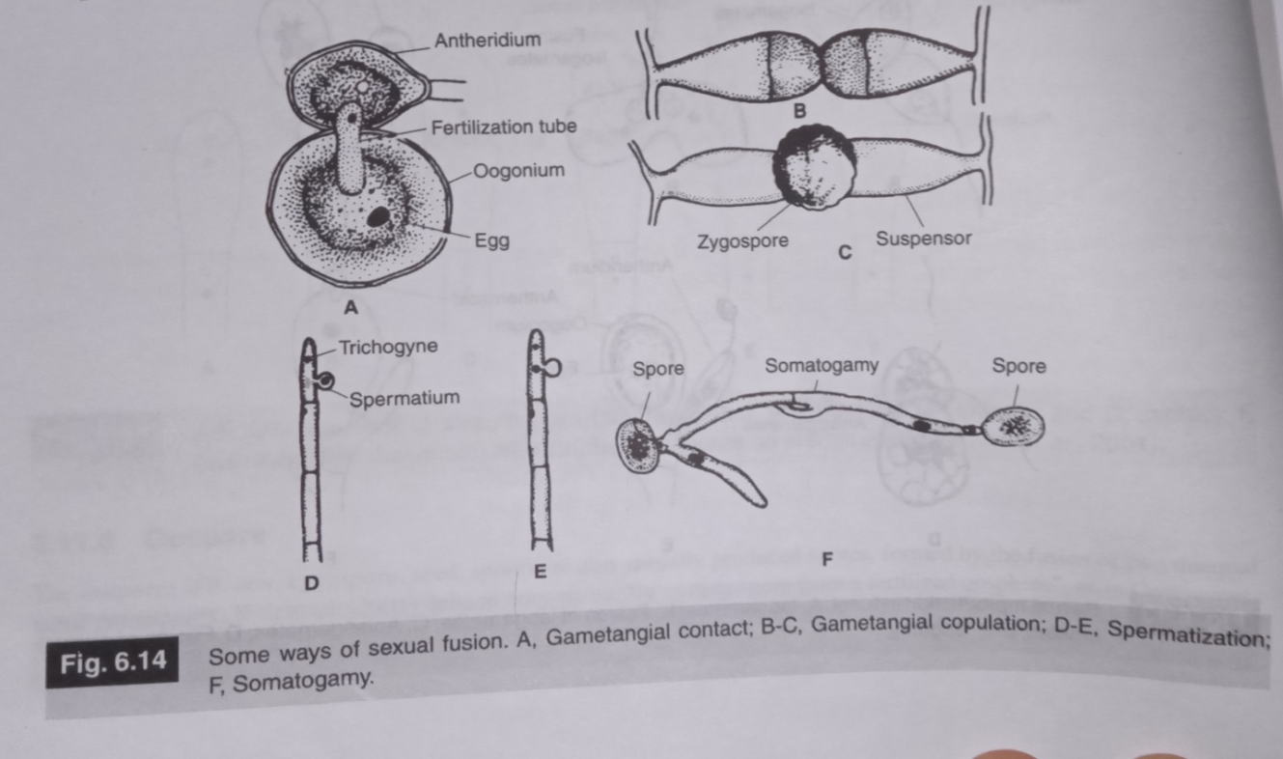
Glossary-
A gametangium is an organ or cell in which gametes are produced that is found in many multicellular protists, algae, fungi, and the gametophytes of plants.
Anastomosis- In mycology, anastomosis is the fusion between branches of the same or different hyphae.

